Mnist Classification using Momentum Features

Youseef Osama Ahmed 20190629

Mohammad Alameen Artan 20190720

y ouseefmoemen293@gmail.com

mohammadalameenartan@gmail.com

In this notebook we used momentum as feature extraction approach for Mnist classification. Each image is 28 × 28 pixels, so we got in total 784 pixel each pixel contains an intensity value ranging from 0 – 255. But instead of using all of them we are going to use the **momentum** for each image which is defined as follow.

*Xc*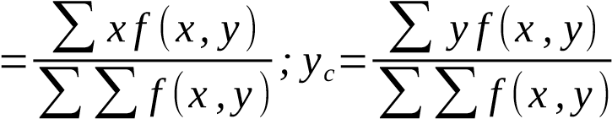

Which is defined the coordination for our momentum, of course we tried different number of sub images calculating the momentum for each sub image which is defined the new feature vector for the whole image the figure below shows us the different images with different number of momentum.

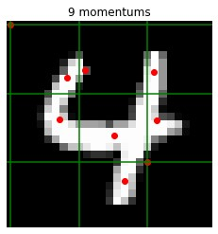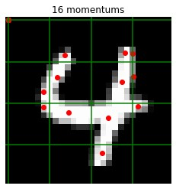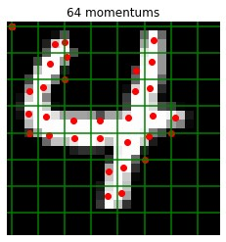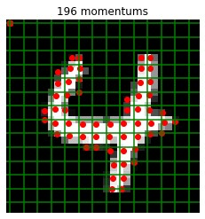

In our last report we discussed using KNN as our model, but due to its simplicity we were looking forward to trying a more complex model that will help us achieve a higher accuracy than our previous model, that model was a neural network from scratch, we experimented with different

architectures like varying number of hidden layers or number of neurons per layer and different activation functions, we tried different learning rates and different epoch sizes, below are the best results we achieved.

Using 100 epochs and 3 hidden layers with varying neurons, we achieved a 64% accuracy.